**1. What are the total sums of freights of ship cities that have orders from 2 or more customers?**

SELECT ShipCity, COUNT(DISTINCT CustomerId) 'Customers', SUM(Freight) 'Total Freight'

FROM 'Order'

GROUP BY 1

HAVING COUNT(DISTINCT CustomerId) >= 2

ORDER BY 3 DESC

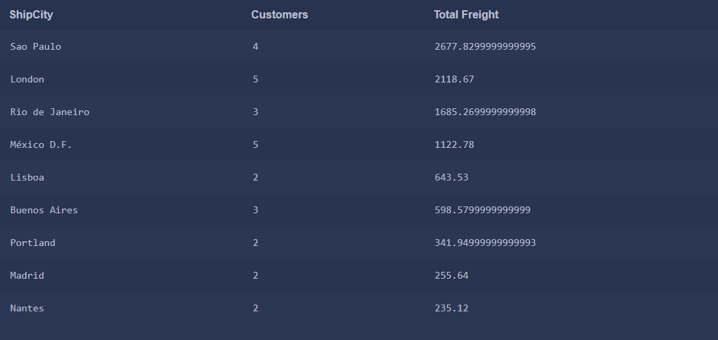

A student’s query might be different but any query that returns these ship cities and corresponding total freight is a valid answer.

**2. Generate a table of employees and the number of customers they handle.**

SELECT e.FirstName, e.LastName, COUNT(DISTINCT o.CustomerId) Customers

FROM 'Order' o

LEFT JOIN Employee e

ON o.EmployeeId = e.Id

GROUP BY 1

ORDER BY 3 DESC

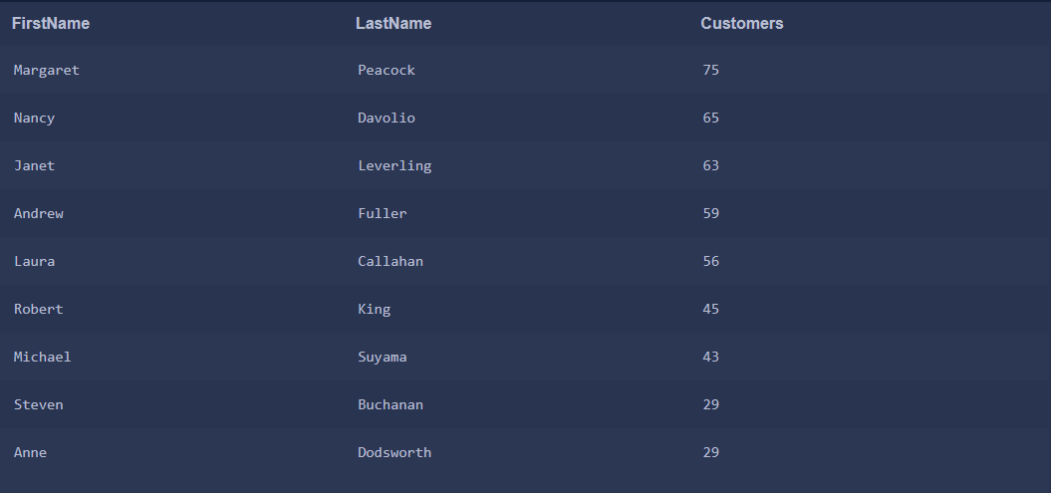

The employee details may be presented differently but they should match the number of customers shown in the results above

**3. How many orders were made each year?**

SELECT strftime('%Y', OrderDate) 'Year', COUNT(Id) Orders

FROM 'Order'

GROUP BY 1

ORDER BY 1

**4. What quantity of the product ‘Chang’ was shipped in 2014?**

SELECT p.ProductName, SUM(od.Quantity) Quantity

FROM 'Order' o

LEFT JOIN OrderDetail od

ON o.Id = od.OrderId

LEFT JOIN Product p

ON od.ProductId = p.Id

WHERE strftime('%Y', OrderDate) = '2014' AND p.ProductName = 'Chang'

GROUP BY 1

**5. What are the revenues per supplier in 2013 before and after discount applied?**

SELECT s.CompanyName Supplier,

SUM(od.UnitPrice * od.Quantity) 'Revenue Before Discount',

SUM((od.UnitPrice * od.Quantity) - (od.UnitPrice * od.Quantity * od.Discount)) 'Revenue After Discount'

FROM OrderDetail od

LEFT JOIN 'Order' o ON od.OrderId = o.Id

LEFT JOIN Product p ON od.ProductId = p.Id

LEFT JOIN Supplier s ON p.SupplierId = s.Id

WHERE strftime('%Y', o.OrderDate) = '2013'

GROUP BY 1

ORDER BY 2 DESC



